C PROGRAMMING
NAME : VISHAAL G
REG NO : 1921260043
COURSE CODE : CSA0222
Task 3: Define the Constants
3.1 Completed program
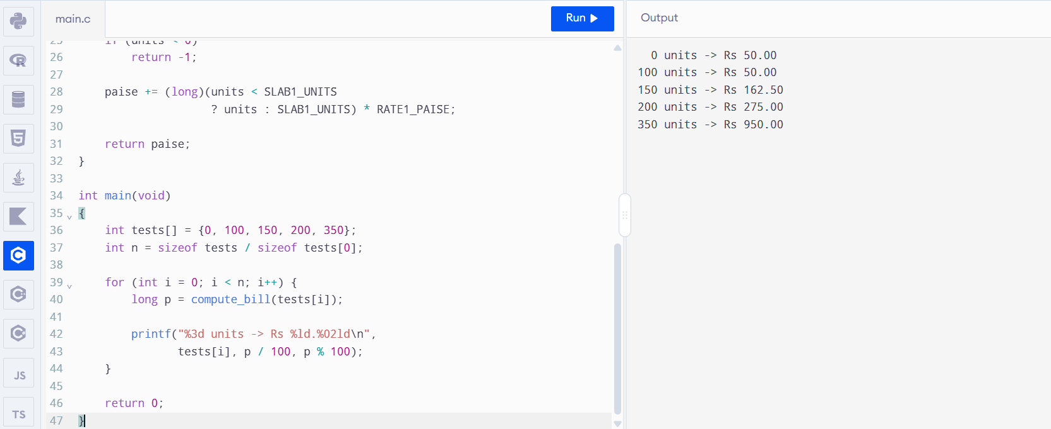
3.2 Difference between #define, const and enum
- #define replaces a name with its value during preprocessing. It does not have a C variable type or normal variable scope.
- const declares an object that cannot be modified through that identifier. It provides type checking and can be visible in a debugger.
- enum defines named integer constants, making it useful for categories and fixed integer choices.
Uppercase names with underscores, such as RATE2_PAISE, are a common convention for macros.

3.3 Tariff revision
Changing:
#define RATE2_PAISE 225
to:
#define RATE2_PAISE 230
changes the second-slab charge everywhere the macro is used. For 150 units, the bill becomes ₹163.00. For 200 units, it becomes ₹276.00.
Complexity: Each bill takes \(O(1)\) time for a fixed number of slabs. The tariff constants use no separate storage as macros; const objects may occupy storage, depending on compilation and use. The running time is effectively unchanged.

